BANK LOAN REPORT QUERY DOCUMENT
BANK LOAN REPORT | SUMMARY

KPI’s:
- Total Loan Applications
SELECT COUNT(id) AS Total_Loan_Applications FROM bank_loan_data;
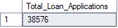
- Month To Date(MTD) Loan Applications
SELECT COUNT(id) AS MTD_Total_Loan_Applications FROM bank_loan_data
WHERE MONTH(issue_date) = 12 AND YEAR(issue_date) = 2021;
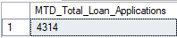
- Previous Month To Date(PMTD) Loan Applications
SELECT COUNT(id) AS PMTD_Total_Loan_Applications FROM bank_loan_data
WHERE MONTH(issue_date) = 11 AND YEAR(issue_date) = 2021;
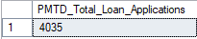
- MTD Total Funded Amount
SELECT SUM(loan_amount) AS MTD_Total_Funded_Amount FROM bank_loan_data
WHERE MONTH(issue_date) = 12 AND YEAR(issue_date) = 2021;
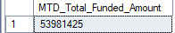

- PMTD Total Funded Amount
SELECT SUM(loan_amount) AS PMTD_Total_Funded_Amount FROM bank_loan_data
WHERE MONTH(issue_date) = 11 AND YEAR(issue_date) = 2021;
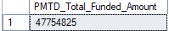

- Total Amount Received
SELECT SUM(total_payment) AS Total_Amount_Received FROM bank_loan_data;
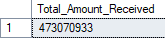

- MTD Total Amount Received
SELECT SUM(total_payment) AS MTD_Total_Amount_Received FROM bank_loan_data
WHERE MONTH(issue_date) = 11 AND YEAR(issue_date) = 2021;
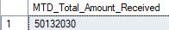
- PMTD Total Amount Received
SELECT SUM(total_payment) AS PMTD_Total_Amount_Received FROM bank_loan_data
WHERE MONTH(issue_date) = 11 AND YEAR(issue_date) = 2021;
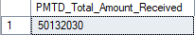
- Total Average Interest Rate(upto 2 decimal)
SELECT ROUND(AVG(int_rate) * 100,2) AS Avg_Interest_Rate FROM bank_loan_data;
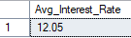
- MTD Average Interest Rate(upto 2 decimal)
SELECT ROUND(AVG(int_rate) * 100,2) AS MTD_Avg_Interest_Rate FROM bank_loan_data
WHERE MONTH(issue_date) = 12 AND YEAR(issue_date) = 2021;
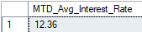
- PMTD Average Interest Rate(upto 2 decimal)
SELECT ROUND(AVG(int_rate) * 100,2) AS PMTD_Avg_Interest_Rate FROM bank_loan_data
WHERE MONTH(issue_date) = 11 AND YEAR(issue_date) = 2021;
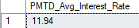
- AVG DTI
SELECT ROUND(AVG(dti) * 100,2) AS Avg_dti FROM bank_loan_data;
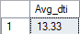
- MTD AVG DTI
SELECT ROUND(AVG(dti) * 100,2) AS MTD_Avg_dti FROM bank_loan_data
WHERE MONTH(issue_date) = 12 AND YEAR(issue_date) = 2021;
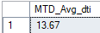
- PMTD AVG DTI
SELECT ROUND(AVG(dti) * 100,2) AS PMTD_Avg_dti FROM bank_loan_data
WHERE MONTH(issue_date) = 11 AND YEAR(issue_date) = 2021;
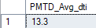
- Good Loan Application Percentage
SELECT
(COUNT(CASE WHEN loan_status = 'Fully Paid' OR loan_status = 'Current' THEN id END) * 100)
/
COUNT(id) AS Good_Loan_Percentage
FROM bank_loan_data;
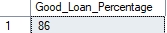

- Total Good Loan Applications
SELECT COUNT(id) AS Total_Good_Loans FROM bank_loan_data
WHERE loan_status = 'Fully Paid' OR loan_status = 'Current';
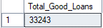
- Good Loan Funded Amount
SELECT SUM(loan_amount) AS Good_Loan_Funded_Amount FROM bank_loan_data
WHERE loan_status = 'Fully Paid' OR loan_status = 'Current';
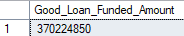
- Good Loan Amount Received
SELECT SUM(total_payment) AS Good_Loan_Amount_Received FROM bank_loan_data
WHERE loan_status = 'Fully Paid' OR loan_status = 'Current' ;
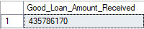

- Bad Loan Application Percentage
SELECT
(COUNT(CASE WHEN loan_status = 'Charged Off' THEN id END) * 100)
/
COUNT(id) AS Bad_Loan_Application_Percentage
FROM bank_loan_data;
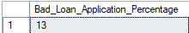
- Total Bad Loan Applications
SELECT COUNT(id) AS Total_Bad_Loans FROM bank_loan_data
WHERE loan_status = 'Charged Off' ;
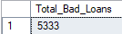

- Bad Loan Funded Amount
SELECT SUM(loan_amount) AS Bad_Loan_Funded_Amount FROM bank_loan_data
WHERE loan_status = 'Charged Off' ;
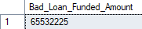
- Good Loan Amount Received
SELECT SUM(total_payment) AS Bad_Loan_Amount_Received FROM bank_loan_data
WHERE loan_status = 'Charged Off' ;
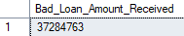
- LOAN STATUS
SELECT
loan_status,
COUNT(id) AS Total_Loan_Applications,
SUM(total_payment) AS Total_Amount_Received,
SUM(loan_amount) AS Total_Funded_Amount,
AVG(int_rate * 100) AS Interest_Rate,
AVG(dti * 100) AS DTI
FROM
bank_loan_data
GROUP BY
loan_status;
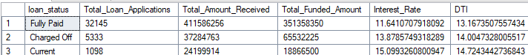

- MTD Loan Status
SELECT
loan_status,
SUM(total_payment) AS MTD_Total_Amount_Received,
SUM(loan_amount) AS MTD_Total_Funded_Amount
FROM bank_loan_data
WHERE MONTH(issue_date) = 12
GROUP BY loan_status;

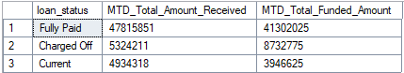

- MONTH
SELECT
MONTH(issue_date) AS Month_Number,
DATENAME(MONTH, issue_date) AS Month_Name,
COUNT(id) AS Total_Loan_Applications,
SUM(loan_amount) AS Total_Funded_Amount,
SUM(total_payment) AS Total_Received_Amount
FROM bank_loan_data
GROUP BY MONTH(issue_date), DATENAME(Month, issue_date)
ORDER BY MONTH(issue_date);
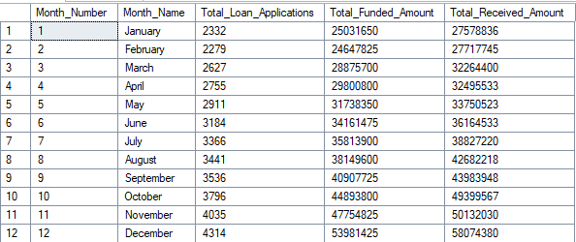

- Regional Analysis by State
SELECT
address_state,
COUNT(id) AS Total_Loan_Applications,
SUM(loan_amount) AS Total_Funded_Amount,
SUM(total_payment) AS Total_Received_Amount
FROM bank_loan_data
GROUP BY address_state
ORDER BY COUNT(id) DESC;
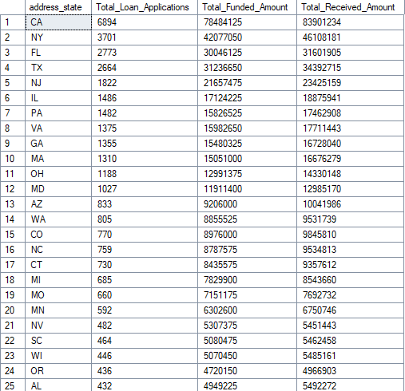
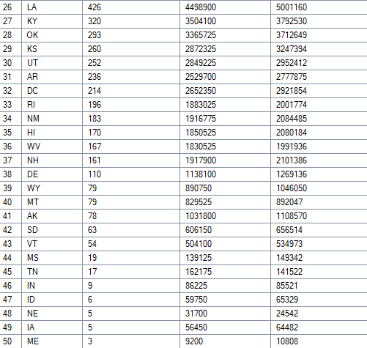

- Long Term Analysis
SELECT
term,
COUNT(id) AS Total_Loan_Applications,
SUM(loan_amount) AS Total_Funded_Amount,
SUM(total_payment) AS Total_Received_Amount
FROM bank_loan_data
GROUP BY term
ORDER BY term;
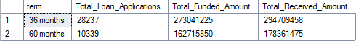
- Total Loan Applications
SELECT
emp_length,
COUNT(id) AS Total_Loan_Applications,
SUM(loan_amount) AS Total_Funded_Amount,
SUM(total_payment) AS Total_Received_Amount
FROM bank_loan_data
GROUP BY emp_length
ORDER BY COUNT(id) DESC;
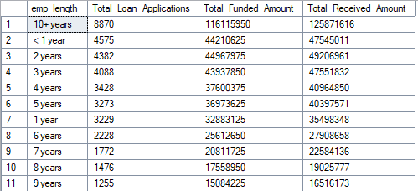

- Purpose
SELECT
purpose,
COUNT(id) AS Total_Loan_Applications,
SUM(loan_amount) AS Total_Funded_Amount,
SUM(total_payment) AS Total_Received_Amount
FROM bank_loan_data
GROUP BY purpose
ORDER BY COUNT(id) DESC;
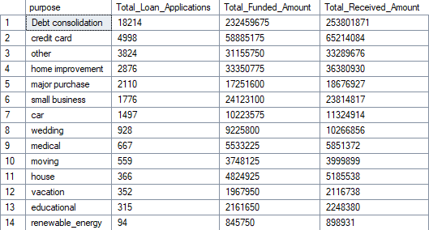

- Home Ownership

SELECT
home_ownership,
COUNT(id) AS Total_Loan_Applications,
SUM(loan_amount) AS Total_Funded_Amount,
SUM(total_payment) AS Total_Received_Amount
FROM bank_loan_data
GROUP BY home_ownership
ORDER BY COUNT(id) DESC;
